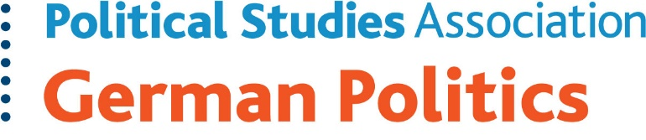

Call for Papers

**German politics in 2023: Historical milestones and contemporary challenges**

The German Politics Specialist Group (GPSG) of the UK Political Studies Association (PSA) is inviting abstract submissions for a two-day, in-person conference to be held on **21 and 22 September** **2023** (Thursday and Friday). The conference will take place at the **University of the West of Scotland’s Paisley campus, just outside Glasgow**.

In 2023, Germany is marking several important anniversaries. It is 75 years since the European Recovery Program, better known as the Marshall Plan, came into effect. 50 years ago, West and East Germany became members of the United Nations, and it has been 25 years since the West German ‘1968 generation’ came into positions of power at the federal level in the red-green coalition government. These milestones have shaped German domestic politics as well as the country’s place in an integrated Europe and a globalised world. In this highly symbolic year, and amidst multiple crises since the late 2000s, the conference invites scholars and practitioners to reflect on the past, present, and future of German politics. Relevant topics include, but are not limited to:

* The legacies of the Cold War and German division,
* Generational conflicts in German politics and changing patterns of political participation and competition,
* Challenges to German liberal democracy from left, right, and beyond,
* Germany as a “country of immigration” – successes and challenges,
* Germany’s socio-economic model, energy politics, and climate change amidst the Russian invasion of Ukraine, and
* Germany’s role on the global stage: *Zeitenwende*, transatlantic relations, and European integration.

We particularly encourage submissions from PhD and post-doctoral researchers. We also welcome comparative papers. Paisley is within easy reach from Glasgow, Edinburgh and Prestwick airports. The conference is free to attend, and there will be limited funding available to support the participation of early-career researchers who are/become members of the PSA (an early career membership is just £20). Coffee and refreshments will be provided during the conference.

**Please send your abstracts** no later than **28 April 2023** to the GPSG’s co-convenor Dr Chantal Sullivan-Thomsett (**C.Sullivan-Thomsett@uea.ac.uk)**. Paper givers are asked to circulate full papers two weeks before the conference. We look forward to your proposals, and please do not hesitate to contact us should you have any questions.

Co-convenors German Politics Specialist Group